Simpson’s 3/8th Rule
Q. Write a program in python to demonstrate Simpson’s 3/8th Rule.
Aim: To write a program in python to demonstrate Simpson’s 3/8th Rule. Program:
import math

def f(x): return math.exp(-x**2)

a = 0

b = 1

n = 6 # number of subintervals (must be a multiple of 3) h = (b - a) / n
x = [a + i * h for i in range(n + 1)] f_values = [f(xi) for xi in x] print("="*70)
print("Simpson’s 3/8 Rule for I = ∫(0 to 1) e^(-x^2) dx") print(" ")
print("i\t x(i)\t\t f(x(i)) = e^(-x^2)")

print(" ")

for i in range(n + 1):

print(f"{i}\t {x[i]:.4f}\t\t {f_values[i]:.6f}")

print(" ")

sum_3 = sum(f_values[i] for i in range(1, n) if i % 3 != 0) sum_2 = sum(f_values[i] for i in range(3, n, 3))
I = (3h/8) * (f_values[0] + 3sum_3 + 2*sum_2 + f_values[-1])

print(f"h = (b - a) / n = ({b} - {a}) / {n} = {h}") print("\nUsing Simpson’s 3/8 Rule:")
print("I = (3h/8) * [f(x0) + 3*(f(x1)+f(x2)+f(x4)+f(x5)+...) + 2*(f(x3)+f(x6)+...) + f(xn)]")

print(f"I = (3*{h}/8) * [{f_values[0]:.4f} + 3*({sum_3:.4f}) + 2*({sum_2:.4f}) + {f_values[- 1]:.4f}]")
print(" ")

print(f"Approximate value of the integral I = {I:.6f}") print("="*70)
Result:
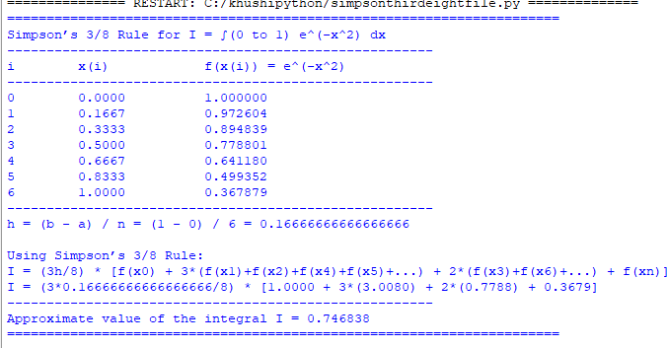

Conclusion: The above program has been executed successfully.

